HTML Task to know usage of basic tags

- Fix the bugs in below snippet

<html lang="en">
<head>
<title>Document guvi</title>
</head>

<body>
<div>Lorem ipsum dolor sit amet consectetur adipisicing elit.</div>
<div>Guvi Geek Network</div>
</body>
</html>

Output:
Lorem ipsum dolor sit amet consectetur adipisicing elit.
Guvi Geek Network

- Try the below one
<html lang="en">
<head>
<title>Document guvi</title>
</head>
<body>
<div>Lorem ipsum dolor sit amet consectetur adipisicing elit.</div>
<div>Guvi Geek Network</div>
</body>
</html>

Output:
Lorem ipsum dolor sit amet consectetur adipisicing elit.
Guvi Geek Network

- Design a contact us form with all fields as required.

<!DOCTYPE html>
<html lang="en">
<head>
<meta charste="UTF-8" />
<meta http-equiv="X-UA_Compatible" content="IE=edge" />
<meta name="viewport" content="width=device-width,initial-scale=1.0" />
<title>Contact us</title>
</head>
<body>
<div>
<form>
<label for="name">Name</label>
<input type="text" name="name" placeholder="Your name" />
<br />
<br />

<label for="phone">Phone</label>
<input type="text" name="phone" placeholder="Your phone number" />
<br />
<br />

<label for="email">Email</label>
<input type="text" name="email" placeholder="Enter your email" />
<br />
<br />

<label for="query">Query</label>
<textarea
name="message"
cols="30"
rows="5"
placeholder="Enter your message"
></textarea>
<br />
<br />

<button type="submit">Submit</button>
</form>
</div>
</body>
</html>

Output:
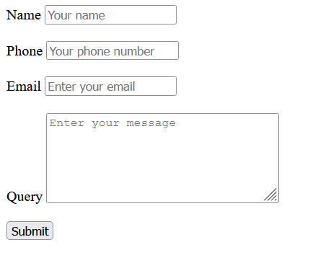

- Use certain HTML elements to display the following in a HTML page.
<!DOCTYPE html>
<html lang="en">
<head>
<meta charset="UTF-8" />
<meta http-equiv="X-UA-Compatible" content="IE=edge" />
<meta name="viewport" content="width=device-width, initial-scale=1.0" />
<title>List</title>
</head>
<body>
<ul>
<li>
Programming Language
<ul>
<li>
JavaScript
<ol type="a">
<li>Angular</li>
<li>React</li>
<li>Vue.js</li>
</ol>
</li>
<li>
Python
<ol type="a">
<li>Django Framework</li>
<li>Flask Framework</li>
</ol>
</li>
<li>
Java
<ol type="a">
<li>Spring</li>
<li>Maven</li>
<li>Hibernate</li>
</ol>
</li>
</ul>
</li>
<li>
Database
<ul>
<li>MySQL</li>
<li>MongoDB</li>
<li>Cansandra</li>
</ul>
</li>
</ul>
</body>
</html>

Output:
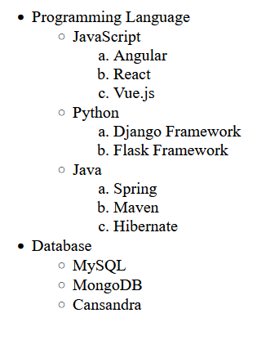

- Create an element that helps you to open the https://google.com in separate new tab.
<!DOCTYPE html>
<html lang="en">
<head>
<meta charset="UTF-8" />
<meta http-equiv="X-UA-Compatible" content="IE=edge" />
<meta name="viewport" content="width=device-width, initial-scale=1.0" />
<title>Open in new tab</title>
</head>
<body>
<a href="https://google.com/" target="_blank">Open google in new tab</a>
</body>
</html>

- In the form, add two radio buttons with grouping them for employee type(Salaried and own business)

<!DOCTYPE html>
<html lang="en">
<head>
<meta charset="UTF-8" />
<meta http-equiv="X-UA-Compatible" content="IE=edge" />
<meta name="viewport" content="width=device-width, initial-scale=1.0" />
<title>RadioButton</title>
</head>
<body>
<div>
<input type="radio" name="salaried" />
<label>Salaried</label>
<br />
<input type="radio" name="business" />
<label>Own business</label>
</div>
</body>
</html>

Output:
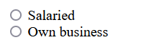

- Design form shown in the link (http://evc-cit.info/cit040/formguide/card_0.png)
HTML:
<!DOCTYPE html>
<html lang="en">
<head>
<meta charset="UTF-8" />
<meta http-equiv="X-UA-Compatible" content="IE=edge" />
<meta name="viewport" content="width=device-width, initial-scale=1.0" />
<link rel="stylesheet" href="zen.css" />
<title>Subscribe Card</title>
</head>
<body>
<div class="container">
<h3 id="title">Yes! I want to subscribe to Mag-O-Zine</h3>

<div class="content-wrapper">
<div class="names">
<div class="name_div">
<p class="reponses_ans">Joe</p>
<p class="form_title">First Name</p>
</div>
<div class="name_div">
<p class="reponses_ans">Schmeggie</p>
<p class="form_title">Last Name</p>
</div>
</div>
<div class="padding1">
<p class="reponses_ans">1001 Washington Street</p>
<p class="form_title ">Address</p>
</div>

<div class="addresses">
<div class="addr">
<p class="reponses_ans">Austin</p>
<p class="form_title">City</p>
</div>
<div class="addr">
<p class="reponses_ans">CA</p>
<p class="form_title">State</p>
</div>
<div class="addr padding2">
<p class="reponses_ans">99999</p>
<p class="form_title ">Zip</p>
</div>
</div>
<h4>
Subscribe for: <input type="checkbox" checked /><label></label>
1year($19.91)</label
>
<input type="checkbox" /><label> 2 years ($35.00)</label>
</h4>
<h4>Send me more information about:</h4>
<div class="more_infos">
<input type="checkbox" checked /><label>Computer-Zine</label>
<br />
<input type="checkbox" /><label>Fishing-Zine</label>
<br />
<input type="checkbox" checked /><label>Cai-O-Zine</label>
</div>
</div>
</div>
</body>
</html>

CSS:
* {
font-style: Helvetica, sans-serif;
margin: 0;
}

.container {
border: 4px solid;
height: 250px;
width: 400px;
}

#title {
margin: 5px 5px;
background-color: red;
text-align: center;
color: white;
}
.content-wrapper {
margin: 10px 10px;
}

.names,
.addresses {
display: flex;
gap: 20px;
}
.addresses {
padding-bottom: 5px;
}
.name_div,
.addr {
flex-grow: 1;
}

.reponses_ans {
border-bottom: 3px solid black;
text-align: center;
font-family: Brush Script MT, Brush Script Std, cursive;
}
.more_infos {
font-weight: bold;
padding-left: 10px;
}

.form_title {
font-size: 13px;
}

.padding1 {
padding-right: 10px;
}

.padding2 {
padding-right: 20px;
}

Output:
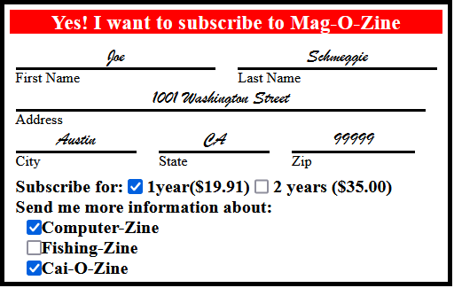
- Use the table tag to design given image Click here.
<!DOCTYPE html>
<html lang="en">
<head>
<meta charset="UTF-8" />
<meta http-equiv="X-UA-Compatible" content="IE=edge" />
<meta name="viewport" content="width=device-width, initial-scale=1.0" />
<title>Health Chart</title>
<style>
.container {
width: 500px;
height: 200px;
}

table,
td,
th {
border: 2px solid;
border-collapse: collapse;
text-align: center;
}
table {
margin-left: 40px;
}
h3 {
text-align: center;
}
</style>
</head>
<body>
<div class="container">
<h3>Health Chart</h3>
<table>
<tr>
<th rowspan="2">State of Health</th>
<th colspan="2">Fasting Value</th>
<th>After Eating</th>
</tr>
<tr>
<th>Minimum</th>
<th>Maximum</th>
<th>2 hours after eating</th>
</tr>
<tr>
<th>Healthy</th>
<td>70</td>
<td>100</td>
<td>Less than 140</td>
</tr>

<tr>
<th>Pre-Diabetes</th>
<td>101</td>
<td>126</td>
<td>140 to 200</td>
</tr>

<tr>
<th>Diabetes</th>
<td>More than 126</td>
<td>N/A</td>
<td>More than 200</td>
</tr>
</table>
</div>
</body>
</html>

Output:
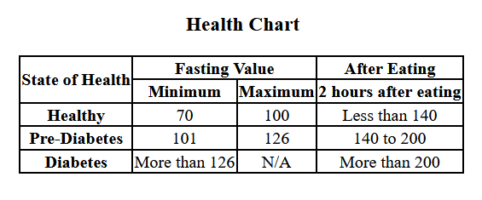
- Write HTML input tags snippet to show default values for all Form elements.
<!DOCTYPE html>
<html lang="en">
<head>
<meta charset="UTF-8" />
<meta http-equiv="X-UA-Compatible" content="IE=edge" />
<meta name="viewport" content="width=device-width, initial-scale=1.0" />
<title>Document</title>
</head>
<body>
<form>
<label for="fname">First name:</label>
<input type="text" name="fname" value="Guvi" /><br /><br />
<label for="lname">Last name:</label>
<input type="text" name="lname" value="Geek" /><br /><br />
<label for="location">Location:</label>
<input type="text" name="location" value="Chennai" /><br /><br />
<input type="submit" value="Submit" />
</form>
</body>
</html>

Output:
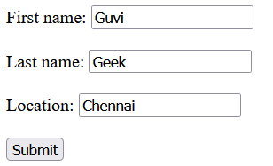
- In your, HTML page add the below line and Highlight it without using any CSS.
- "HTML & CSS is awesome"
<!DOCTYPE html>
<html lang="en">
<head>
<meta charset="UTF-8" />
<meta http-equiv="X-UA-Compatible" content="IE=edge" />
<meta name="viewport" content="width=device-width, initial-scale=1.0" />
<title>Highlight in HTML</title>
</head>
<body>
<ul>
<li><mark>"HTML & CSS is awesome"</mark></li>
</ul>
</body>
</html>

Output:
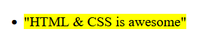
- Create an HTML page, which should contain all types of input elements.

<!DOCTYPE html>
<html lang="en">
<head>
<meta charset="UTF-8" />
<meta http-equiv="X-UA-Compatible" content="IE=edge" />
<meta name="viewport" content="width=device-width, initial-scale=1.0" />
<title>Input types</title>
<link
href="https://cdn.jsdelivr.net/npm/bootstrap@5.1.3/dist/css/bootstrap.min.css"
rel="stylesheet"
integrity="sha384-1BmE4kWBq78iYhFldvKuhfTAU6auU8tT94WrHftjDbrCEXSU1oBoqyl2QvZ6jIW3"
crossorigin="anonymous"
/>
<style>
.my_class_container {
border: 1px solid;
padding-bottom: 20px;
padding-left: 30px;
width: 70%;
}
.top {
display: flex;
justify-content: space-around;
padding: 20px;
}
</style>
</head>
<body>
<div class="top">
<div>
<h1>Product registration form</h1>
</div>
<div>
<input type="search" />
<button class="btn btn-info">Search</button>
</div>
</div>
<form class="container rounded-3 my_class_container">
<br /><br />
<div>
<label class="form-label" for="name">Name </label>
<input type="text" required maxlength="50" />
</div>
<br />
<div>
<label class="form-label" for="gender">Gender </label>
<input class="form-check-input" type="radio" />
<label class="form-check-label" for="male">Male</label>
<input class="form-check-input" type="radio" />
<label class="form-check-label" for="female">Female</label>
</div>
<br />
<div>
<label class="form-label" for="phone">Phone</label>
<input type="tel" placeholder="123-4567-8901" required />
</div>
<br />
<div>
<label class="form-label" for="email">Email</label>
<input type="email" />
</div>
<br />
<div>
<label class="form-label" for="image">Product Image</label>
<input type="file" required />
</div>
<br />
<div>
<label class="form-label" for="theme">Color</label>
<input type="color" />
</div>
<br />
<div>
<label class="form-label" for="quantity">Quantity</label>
<input type="number" min="1" max="3" required />
</div>
<br />
<div>
<p class="form-label">Choose Add-ons:</p>
<div>
<input class="form-check-input" type="checkbox" name="wrap" />
<label class="form-check-label" for="wrap">Gift wrap</label>
</div>

<div>
<input
class="form-check-input"
type="checkbox"
name="delivery_type"
/>
<label class="form-check-label" for="delivery_type"
>Express delivery</label
>
</div>

<div>
<input class="form-check-input" type="checkbox" name="packing" />
<label class="form-check-label" for="packing">Premium packing</label>
</div>

<div>
<input class="form-check-input" type="checkbox" name="luck" checked />
<label class="form-check-label" for="luck">Lucky draw</label>
</div>
</div>

<br />
<div>
<label class="form-label" for="date">Preferred Date </label>
<input type="date" />
<input type="time" />
</div>
<br />
<div>
<label class="form-label" for="pwd">Delivery PIN</label>
<input type="password" maxlength="5" required />
</div>
<br />
<div>
<label class="form-label" for="comments">Comments</label>
<input type="text" maxlength="500" />
</div>
<br />
<div>
<label for="rating" class="form-label">Booking experience</label>
<input type="range" name="rating" min="0" max="5" />
</div>
<br />
<input class="btn btn-primary" type="submit" value="Submit" />
</form>
</body>
</html>

Output:
